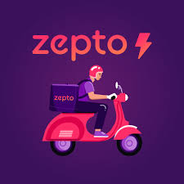

**Product Dissection for Zepto**

**Company Overview:**

Zepto is a rapidly growing quick commerce startup that has gained significant traction in India's urban areas. Founded in 2021 by Aadit Palicha and Kaivalya Vohra, two 19-year-old entrepreneurs from Stanford University, Zepto aims to revolutionize the way people shop for daily essentials by providing deliveries in under 10 minutes.

The company operates through a network of dark stores (mini-warehouses) strategically located in high-density residential areas, enabling rapid fulfillment of orders. Zepto's innovative approach has disrupted the traditional grocery delivery model, catering to the growing demand for instant gratification and convenience among urban consumers.

Zepto is an ultra-fast grocery delivery service founded by Aadit Palicha and Kaivalya Vohra. Launched with the mission to revolutionize the grocery delivery landscape, Zepto promises delivery within 10 minutes. Leveraging a network of micro-warehouses and advanced logistics technology, Zepto addresses the need for convenience and speed in urban grocery shopping.

**Product Dissection and Real-World Problems Solved by Zepto:**

Zepto's core offering revolves around addressing the real-world problem of inefficient and time-consuming grocery shopping experiences. Zepto provides a seamless and rapid grocery delivery service through a mobile application. The app connects users with nearby micro-warehouses stocked with a variety of groceries and essentials. This service solves several real-world problems such as the need for last-minute grocery runs, long queues at supermarkets, and the hassle of finding specific items quickly by leveraging advanced technology and a lean supply chain, thus, Zepto provides a seamless and convenient solution for consumers seeking instant access to everyday essentials.

**Case Study: Real-World Problems and Zepto's Innovative Solutions**

**Problem 1: Time-Consuming Grocery Shopping**

**Real world challenge:** Traditional grocery shopping often involves long queues, traffic congestion, and extended travel times, leading to frustration and inconvenience for consumers.

**Solution:** Zepto’s promise of 10-minute delivery eliminates the need for time-consuming trips to the grocery store saving consumers valuable time and effort. Users can place orders from the comfort of their homes and receive items almost instantly.

**Problem 2: Limited Store Hours**

**Real world challenge**: Most traditional grocery stores operate within fixed hours, typically from early morning until late evening. Common store hours might be from 8 AM to 10 PM, depending on the location and store type. This limitation can be inconvenient for many customers such as working professionals with busy schedules or customers with some emergency needs.

**Zepto's Solution:** By providing a 24/7 grocery delivery service, Zepto effectively solves the problem of limited store hours. This innovation not only caters to the diverse schedules and needs of modern consumers with busy urban lifestyle, non-traditional work hours or sudden late-night needs. but also enhances the overall convenience and accessibility of grocery shopping. The continuous availability of Zepto’s service ensures that customers can rely on them for their grocery needs at any time, making it a standout feature that significantly improves the user experience.

**Problem 3: Inefficient Supply Chain and Inventory Management**

**Real world challenge**: Traditional grocery retailers often struggle with inefficient supply chain management, leading to stockouts, wastage, and suboptimal inventory management.

**Zepto's Solution:** Zepto's data-driven approach and lean supply chain enable efficient inventory management, minimizing waste, and ensuring product availability and also the micro-warehouses are stocked based on local demand patterns, reducing the chances of stockouts.

**Problem 4:**  **Limited Availability of Fresh Produce:**

**Real world challenge**: Accessing fresh, high-quality produce can be challenging for urban dwellers, as traditional grocery stores may have limited stock or sourcing capabilities.

**Zepto's Solution:** Zepto partners with local farms and suppliers to ensure a steady supply of fresh produce. Zepto guarantees the freshness of products by Their efficient supply chain and strategically located dark stores enable the rapid delivery of fresh fruits and vegetables, ensuring customers have access to high-quality, locally sourced produce.

**Problem 5: Lack of Personalization and Curated Experiences:**

**Real world challenge**: Conventional grocery shopping experiences often lack personalization and tailored recommendations, making it challenging for consumers to discover new products or make informed choices.

**Zepto's Solution:** By leveraging customer data and AI-powered recommendation engines, Zepto can provide personalized product suggestions and curated experiences, enhancing customer satisfaction and loyalty.

**Problem 6: Difficulty in Navigating Large Stores and Finding Products:**

Traditional grocery stores can be overwhelming, with vast product selections and complex layouts, making it challenging for customers to find what they need efficiently.

**Zepto's Solution:** Zepto's user-friendly mobile app offers a streamlined browsing experience, allowing customers to easily search and filter products based on their preferences and dietary requirements. The app's intuitive interface and smart search functionality simplify the shopping experience, saving customers time and effort.

**Problem 7:** **Lack of Transparency in Traditional Grocery Delivery:**

**Real world challenge**: Traditional grocery delivery services often lack transparency, making it difficult for customers to track the status of their orders or know the exact delivery time.

**Zepto's Solution:** Zepto provides real-time order tracking, allowing customers to monitor the progress of their deliveries and receive accurate estimated delivery times. This transparency enhances the overall customer experience and builds trust in the service.

**Problem 8:** **Lack of Sustainable Packaging and Delivery Options:**

**Real world challenge:** Traditional grocery delivery services often rely on excessive packaging and inefficient delivery methods, contributing to environmental pollution and waste.

**Zepto's Solution:** Zepto prioritizes sustainable practices by implementing eco-friendly packaging solutions and optimizing delivery routes to reduce carbon emissions. Additionally, Zepto promotes the use of reusable and recyclable packaging materials, contributing to a more environmentally conscious approach to grocery delivery.

**Conclusion:**

Zepto stands out by effectively addressing common pain points in the grocery shopping experience. By leveraging technology and data-driven approaches, Zepto has disrupted the traditional grocery delivery model providing a seamless and efficient way for consumers to access daily essentials.

The platform's standout features, such as ultra-fast delivery, 24/7 availability, strategic warehouse placement, efficient inventory management, a commitment to product freshness, personalization, user-friendly mobile app, transparency, and sustainability, collectively enhance user experience and align with the core objective of providing rapid and reliable grocery delivery and positions it as a disruptive force in the quick commerce industry, catering to the evolving needs and preferences of urban consumers.

**Top Features of Zepto**

**1. Ultra-Fast Delivery:** Zepto's core offering is its ability to deliver groceries and household essentials within 10 minutes, addressing the need for instant gratification and convenience.

**2. 24/7 Availability:** Operates round the clock, catering to late-night and early-morning needs.

**3. User-Friendly Mobile App**: Zepto's intuitive mobile app allows users to browse products, place orders, track deliveries, and manage their accounts seamlessly.

**4. Real-Time Order Tracking:** Customers can track their orders in real-time, providing transparency and enhancing the overall delivery experience.

**5. Vast Product Assortment:** Zepto offers a comprehensive range of products, including fresh produce, packaged goods, household items, and personal care products, catering to diverse consumer needs.

**6.** **Flexible Payment Options:** Zepto offers various payment options, including cash on delivery, digital wallets, and various secure online payment gateways, catering to diverse customer preferences.

**Schema Description**

Based on the identified features, the schema design reflects the data structure needed to support Zepto’s operations:

**User Entity:**

Users are at the core of Zepto. The user entity contains information about each user:

* **UserID (Primary Key):** A unique identifier for each user.
* **Name**: The user's full name.
* **Email:** The user's email address for account-related communication.
* **Phone:** The user's phone number.
* **Address:** The user's delivery address.
* **Preferences:** The user's preferences for product categories, dietary restrictions, or favourite items.

**Product Entity:**

Products represent the items available for purchase on Zepto:

* **ProductID (Primary Key):** A unique identifier for each product.
* **Name:** The name of the product.
* **Description:** A detailed description of the product.
* **Category:** The category to which the product belongs (e.g., groceries, household items, personal care).
* **Price**: The selling price of the product.
* **Inventory Level**: The current inventory level of the product.

**Order Entity:**

Orders capture the details of user purchases:

* **OrderID (Primary Key):** A unique identifier for each order.
* **UserID (Foreign Key referencing User Entity):** The user who placed the order.
* **OrderDate:** The date and time when the order was placed.
* **DeliveryInstructions:** Any specific instructions provided by the user for delivery.
* **OrderStatus:** The current status of the order (e.g., pending, processing, delivered).
* **Quantity:** The quantity of the product ordered.

**OrderItem Entity:**

OrderItems represent the individual items included in an order:

* **OrderItemID (Primary Key)**: A unique identifier for each order item.
* **OrderID (Foreign Key referencing Order Entity)**: The order to which the item belongs.
* **ProductID (Foreign Key referencing Product Entity)**: The product included in the order item.
* **Quantity**: The quantity of the product ordered.

**Inventory Entity:**

Inventory tracks the stock levels of products in each dark store:

* **InventoryID (Primary Key):** A unique identifier for each inventory record.
* **DarkStoreID (Foreign Key referencing DarkStore Entity):** The dark store to which the inventory record belongs.
* **ProductID (Foreign Key referencing Product Entity):** The product associated with the inventory record.
* **StockLevel:** The current stock level of the product in the dark store.

**DarkStore Entity:**

DarkStores represent Zepto's mini-warehouses or fulfillment centres:

* **DarkStoreID (Primary Key):** A unique identifier for each dark store.
* **Location**: The physical location of the dark store.
* **Capacity**: The maximum storage capacity of the dark store.
* **OperationalDetails**: Any additional operational details about the dark store.

**Payment Entity:**

Payments store information about order transactions:

* **PaymentID (Primary Key):** A unique identifier for each payment.
* **OrderID (Foreign Key referencing Order Entity):** The order associated with the payment.
* **PaymentMethod:** The method of payment used (e.g., credit card, digital wallet).
* **TransactionDetails**: Any additional details related to the payment transaction.
* **TotalAmount:** The total amount paid for the order.

**Delivery Entity:**

Deliveries manage the logistics and tracking of order deliveries:

* **DeliveryID (Primary Key):** A unique identifier for each delivery.
* **OrderID (Foreign Key referencing Order Entity):** The order associated with the delivery.
* **DeliveryPersonnel:** Information about the personnel responsible for the delivery.
* **DeliveryRoute:** The planned route for the delivery.
* **EstimatedTime:** The estimated time of delivery.

**Relationships are:**

* **Users place Orders:**
* Each user can place multiple orders.
* This relationship represents the one-to-many relationship between the User and Order entities.
* **Orders contain Products:**
* Each order can contain multiple products.
* Each product can be part of multiple orders.
* This relationship represents the many-to-many relationship between the Order and Product entities, facilitated by the Quantity attribute in the Order entity.
* **OrderItems are associated with Products:**
* Each order item is associated with one product.
* Each product can be part of multiple order items across different orders.
* This relationship represents the many-to-one relationship between the OrderItem and Product entities.
* **Products are tracked in Inventory:**
* Each product can have stock levels tracked in multiple inventory records across different dark stores.
* Each inventory record is associated with one product.
* This relationship represents the one-to-many relationship between the Product and Inventory entities.
* **Inventory is maintained in DarkStores:**
* Each inventory record is associated with one dark store.
* Each dark store can have multiple inventory records for different products.
* This relationship represents the many-to-one relationship between the Inventory and DarkStore entities.
* **Orders have Payments:**
* Each order is associated with one payment.
* Each payment is associated with one order.
* This relationship represents the one-to-one relationship between the Order and Payment entities.
* **Orders have Deliveries:**
* Each order is associated with one delivery.
* Each delivery is associated with one order.
* This relationship represents the one-to-one relationship between the Order and Delivery entities.

This schema design aims to capture the essential entities and the relationships between the entities in the Zepto schema are clearly defined, facilitating an understanding of how the different components interact and connect with each other to support Zepto's operations, enabling efficient data management, inventory tracking, personalization, order processing, and delivery logistics.

**Rationale and Strategy:**

The schema design for Zepto was carefully crafted to align with the platform's core objectives and operational requirements. Several design elements were strategically chosen to ensure efficient data management, seamless order processing, personalized user experiences, and robust inventory tracking. Here's the rationale and strategy behind the key design choices:

**User Entity:**

The User entity serves as the foundation for personalization and user-centric experiences, which are crucial for Zepto's success. By capturing user preferences, addresses, and other relevant information, the platform can tailor recommendations, streamline delivery logistics, and provide a seamless shopping experience tailored to individual needs.

**Product Entity:**

The Product entity is central to Zepto's ability to manage its vast product assortment. By capturing detailed information about each product, including its name, description, category, and price, the platform can provide users with comprehensive product details and enable efficient search and filtering functionalities. The InventoryLevel attribute within the Product entity allows for real-time tracking of overall stock availability, facilitating effective inventory management and order fulfillment.

**Order Entity:**

The Order entity is critical for capturing customer purchases and enabling order processing and tracking. By associating each order with a user and capturing relevant details such as order date, delivery instructions, and status, Zepto can effectively manage the order lifecycle and provide customers with real-time updates.

The Quantity attribute within the Order entity allows for flexible order composition, enabling customers to order multiple quantities of the same product in a single order.

**OrderItem Entity:**

The OrderItem entity enables the many-to-many relationship between Orders and Products, allowing flexible order composition with multiple products per order. It captures granular order details like product quantity, adheres to normalization principles, provides flexibility in order modifications, enhances scalability and reporting capabilities, and allows for future extensibility related to order item attributes.

**Inventory Entity:**

The Inventory entity, in conjunction with the DarkStore entity, enables Zepto to manage inventory levels across its network of dark stores. By capturing the stock level of each product at each dark store location, the platform can optimize inventory allocation, distribution, and order fulfillment based on real-time stock availability.

**DarkStore Entity:**

The DarkStore entity represents Zepto's strategic network of mini-warehouses, enabling rapid fulfillment and delivery. By capturing information about each dark store's location, capacity, and operational details, the platform can optimize inventory allocation, distribution, and logistics planning.

**Payment Entity:**

The Payment entity facilitates seamless order processing and transaction management. By capturing payment details such as the payment method, transaction details, and total amount, Zepto can ensure secure and transparent financial transactions, aligning with its commitment to customer satisfaction and trust.

**Delivery Entity:**

The Delivery entity enables Zepto to manage the logistics and tracking of order deliveries effectively. By capturing delivery personnel information, planned routes, and estimated delivery times, the platform can optimize its delivery operations, provide customers with real-time tracking updates, and maintain its promise of rapid deliveries.

Overall, the schema design emphasizes data organization, scalability, and efficient operations, enabling Zepto to deliver on its promise of rapid and convenient access to everyday essentials. By strategically structuring the entities and their relationships, the platform can effectively address real-world challenges faced by urban consumers while maintaining a lean and agile operational model.

**ER Diagram**

Let's construct an ER diagram that vividly portrays the relationships and attributes of the entities within the Zepto’s schema. This ER diagram will serve as a visual representation, shedding light on the pivotal components of Zepto’s data model. By employing this diagram, we'll gain a clearer grasp of the intricate interactions and connections that define the platform's dynamics.

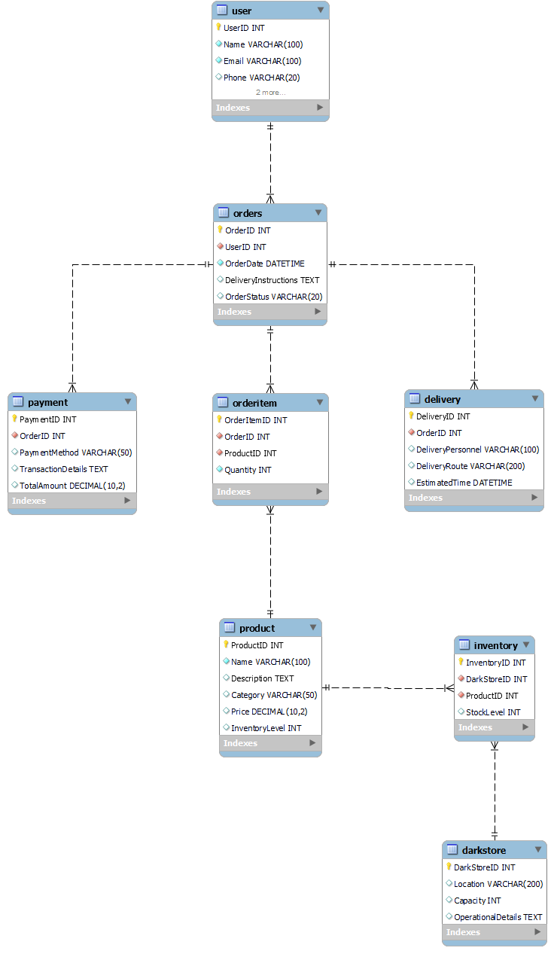**Conclusion:**

Zepto's innovative approach to quick commerce has disrupted the traditional grocery delivery model, addressing real-world challenges faced by urban consumers. By leveraging advanced technology, data-driven approaches, and a lean supply chain, Zepto offers convenient and personalized solutions for accessing daily essentials.

The schema design presented in this case study reflects Zepto's core functionalities and operational requirements, capturing key entities and relationships necessary for efficient inventory management, personalized recommendations, order processing, and delivery logistics.

As Zepto continues to expand its reach and enhance its offerings, the schema design may evolve to accommodate new features and operational requirements. However, the fundamental principles of efficient data organization, user-centric design, and seamless integration of various components will remain crucial for Zepto's continued success in the quick commerce landscape.